*Core Java - Objects Assignment*

**Instructions:**

Below you will find a series of assignments that you will complete in this exercise. You will need to create a new project folder for this task and name it **Java_Assignment_9_Objects**. You can use the default settings when creating the new project.

For each of the below assignments you will create new classes as specified below. You can keep them in the default package.

Most classes will NOT declare a main() method except for the Application.java file that you will write for a package. In your assignments, you will execute the main() method of the Application.java file.

**Assignments**

1. Write a class **MyObject** that declares a property id (long). Override the equals method to compare two objects and if the following occurs, returns true:
   1. The second object is of type MyObject
   2. The second object has an id property that is equal to this MyObject’s id property.

You will need to write an Application class to create two instances of MyObject that have the same value for their id property. Write a conditional statement to test if the two objects are equivalent using the .equals() method of your MyObject class. Print statements in the true condition and in the false condition.

For this exercise, you’ll need to use the **instanceof** operator to check if a class is the same type as another.

ex:

|  |
| --- |
| if (o instanceof SomeObject) { … } |

**Goal:**

The purpose of this assignment is to provide you practice with writing classes that makes use of the Object class. You will utilize the **main()** method of your classes to execute a particular goal of the assignment. This main() method should be implemented in a Application.java file.

By the end of this assignment, you will have 1 new project folder.

**Helpful Notes**

Project Structure:

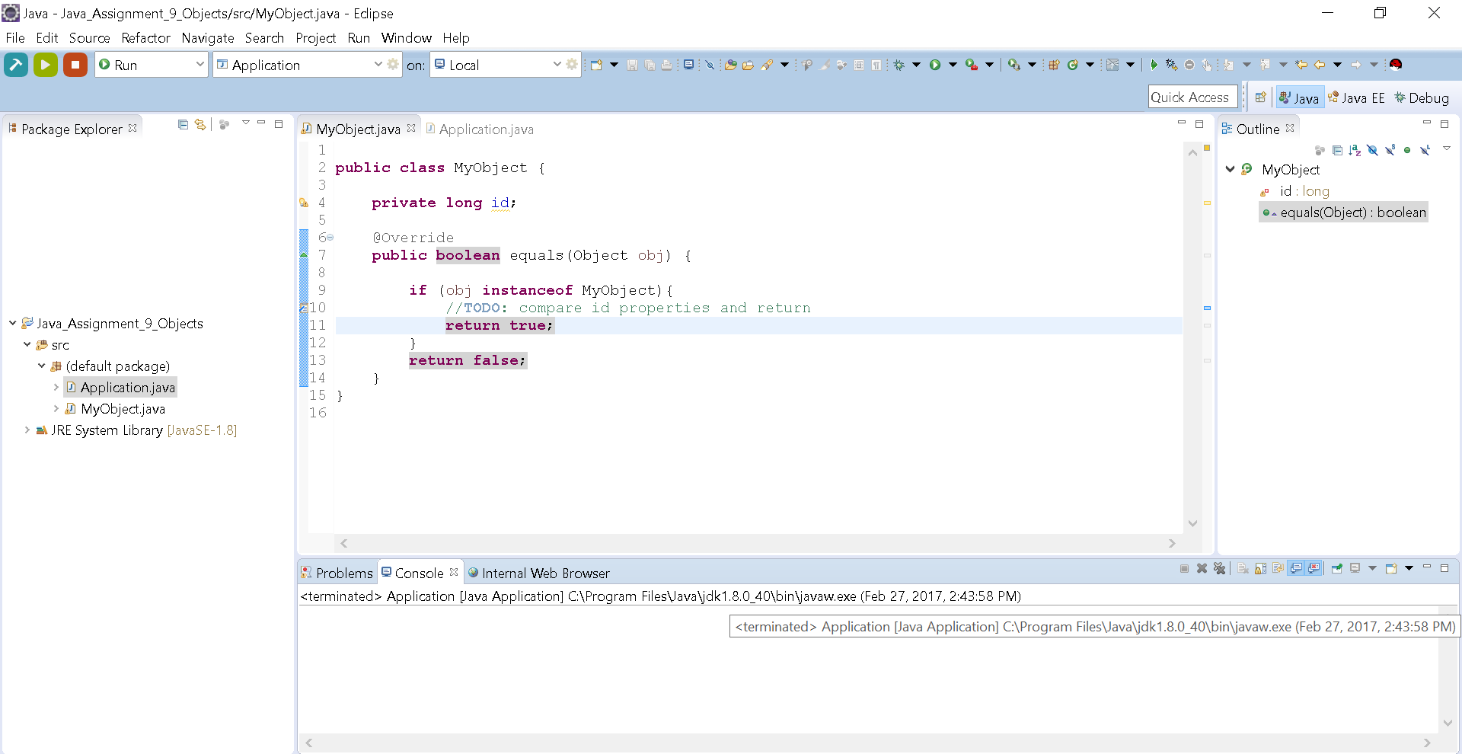

* Your project structure should resemble the above. Note that the name of the project is **Java_Assignment_9_Objects** and all class files are named according to the associated assigned number

Assignment Classes:

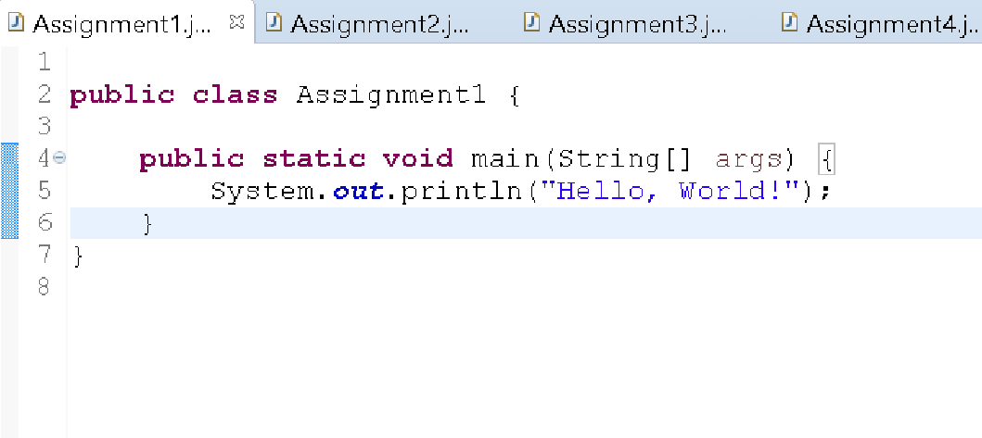

* Notice the indentation of the statement on line 5 to show that it is part of the main() method. Likewise, your code should follow this pattern.